Runge-Kutta-Fehlberg Method: Numerical Solution and Computer Performance Analysis

Project 2 – Runge-Kutta-Fehlberg (RKF) for ODE
CST-305: Principles of Modeling and Simulation Design
Jordan Cruze
Dr. Citro
10/03/2026

GitHub Link: https://github.com/Jordan-Cruze/CST-305
- Responsibilities and Completed Tasks
Team Member Responsibilities
Jordan Cruze
- Solved the assigned ordinary differential equation (ODE) manually using the Runge-Kutta-Fehlberg 45 (RKF45) method.
- Derived the true analytical solution for comparison.
- Developed and tested the Python implementation of the RKF45 algorithm.
- Compared the manually calculated results with the program results.
- Documented the mathematical method and computational approach.
- Prepared the project documentation and README file.

- System Performance Context
The purpose of this assignment is to use the Runge-Kutta-Fehlberg (RKF) method to solve an ordinary differential equation and then use a computer implementation of the same method to evaluate computational performance.
The computational performance of the system is evaluated by measuring the amount of time required to perform a large number of numerical calculations. The program performs between 1,000 and 2,000 numerical solution steps and records the total number of computational steps and the elapsed execution time.
The computer used for this project is:
- Operating System: Windows 11
- Processor: Intel Core i9 14900HX
- RAM: 32GB DDR5
- Python Version: Python 3.14.7
- Development Environment: VS Code
- Python Packages: SciPy, NumPy, ODEint
The execution time may vary depending on the computer's processor, memory, operating system, Python implementation, background processes, and the number of calculations performed.

3. Specific Problem Solved
The assigned ordinary differential equation is:
$$\frac{dy}{dx}=\frac{y}{e^{x}-1}$$
with the initial conditions:
$$x_{0}=1, y_{0}=5$$
and step size:
$$h=0.02$$

The objective of the first part of the assignment is to manually calculate the numerical solution at:
$$\left(x_{0},y_{0}\right), \left(x_{1},y_{1}\right), \left(x_{2},y_{2}\right), \left(x_{3},y_{3}\right), \left(x_{4},y_{4}\right), \left(x_{5},y_{5}\right)$$

Since the step size is 0.02, the corresponding x values are:
$$x_{0}=1.00, x_{1}=1.02, x_{2}=1.04, x_{3}=1.06, x_{4}=1.08, x_{5}=1.10$$

The function used by the RKF method is:
$$f(x,y)=\frac{y}{e^{x}-1}$$

- Mathematical Approach
  - Runge-Kutta-Fehlberg 45 Method
The Runge-Kutta-Fehlberg 45 (RKF45) method is a numerical method for approximating solutions to first-order ordinary differential equations. The method calculates two approximations of the solution at each step: a fourth-order approximation and a fifth-order approximation.
For the differential equation:
$$y^{'}=f(x_{n},y_{n})$$

the six intermediate values are calculated as follows:
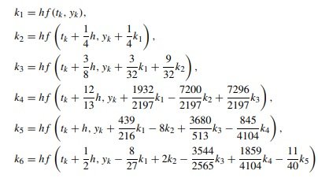

The fourth-order approximation is given by:
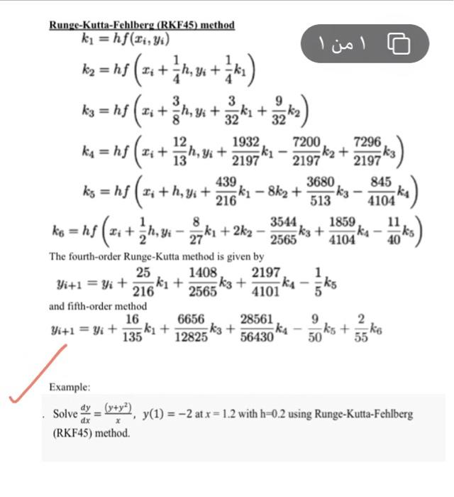
The fifth-order approximation is given by:

For this assignment, the fifth-order approximation is used as the RKF solution.
  - Manual RKF Solution
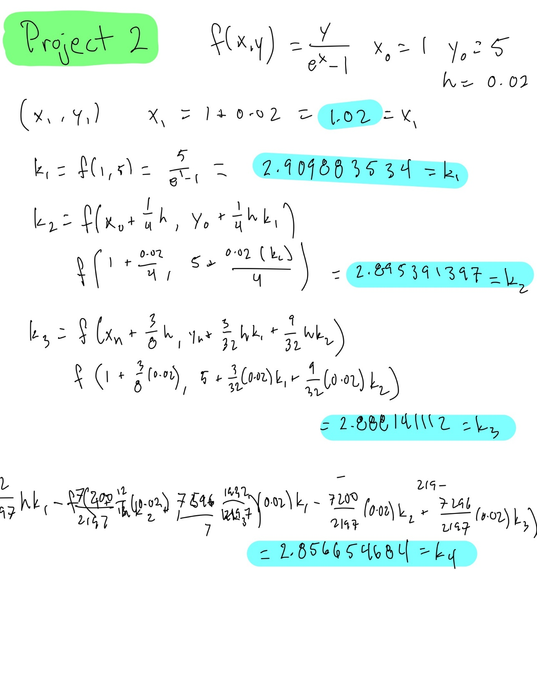
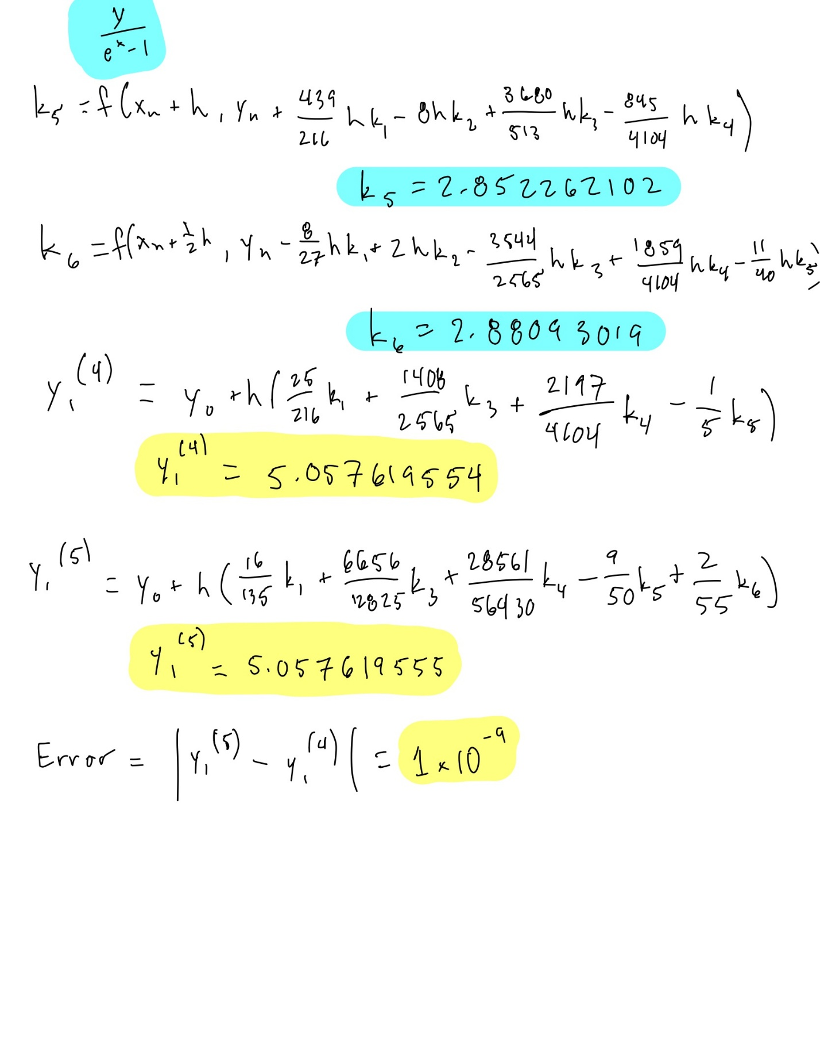

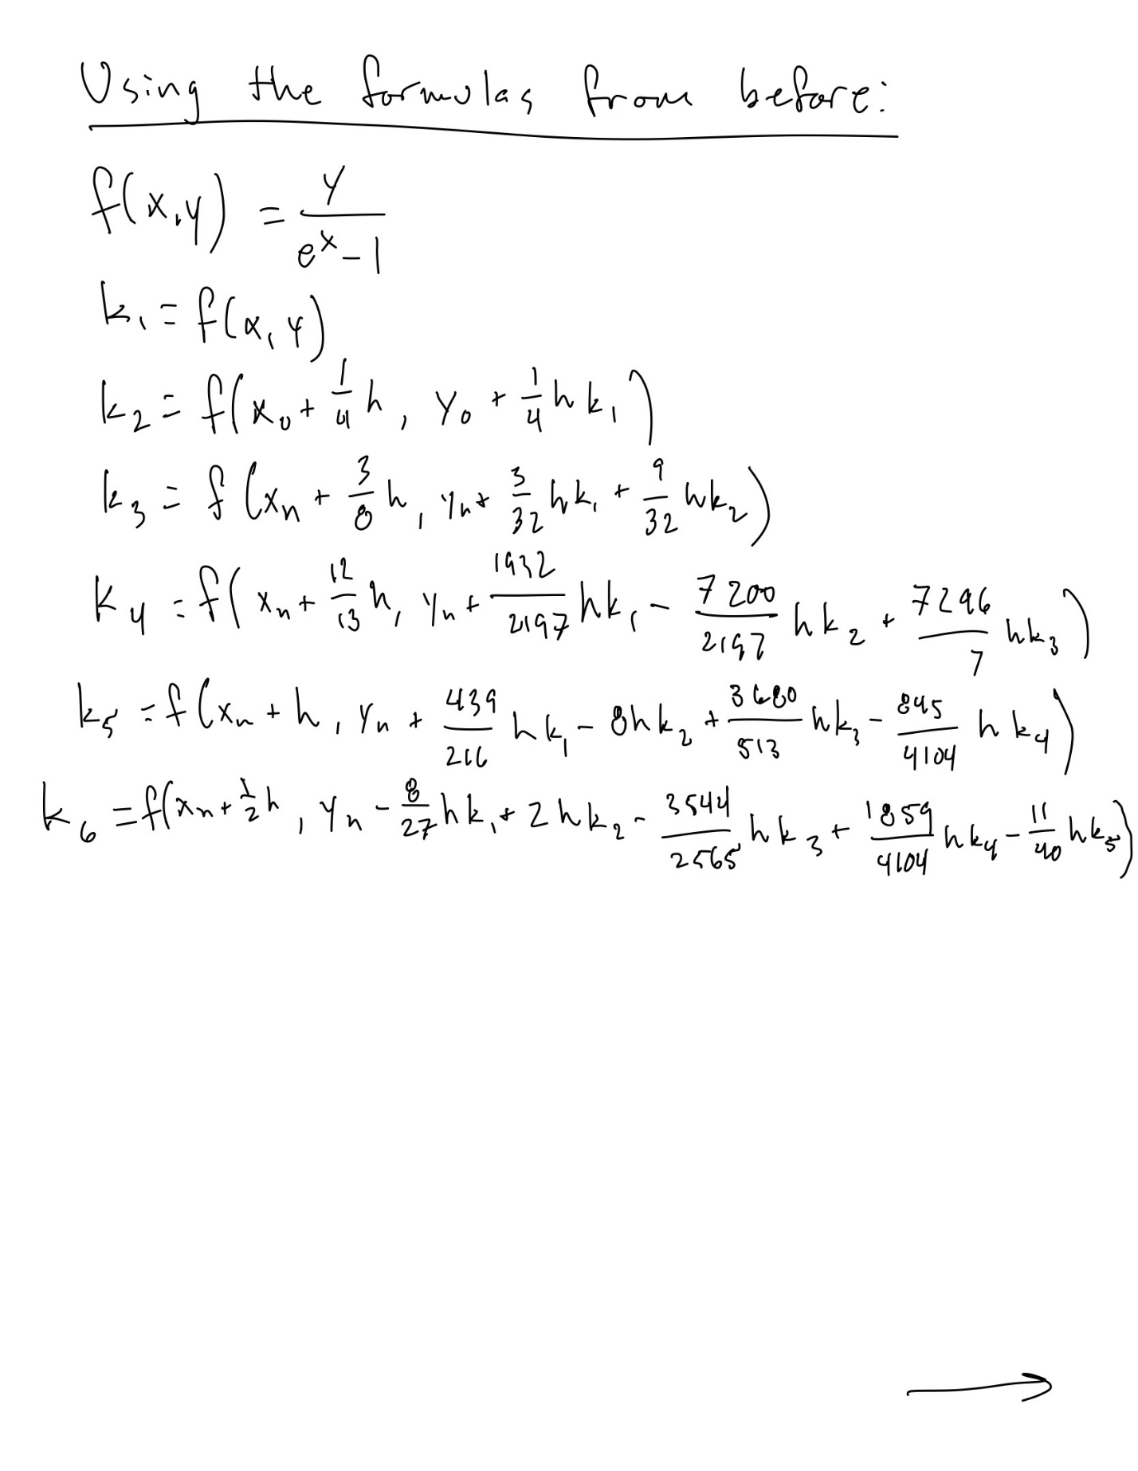

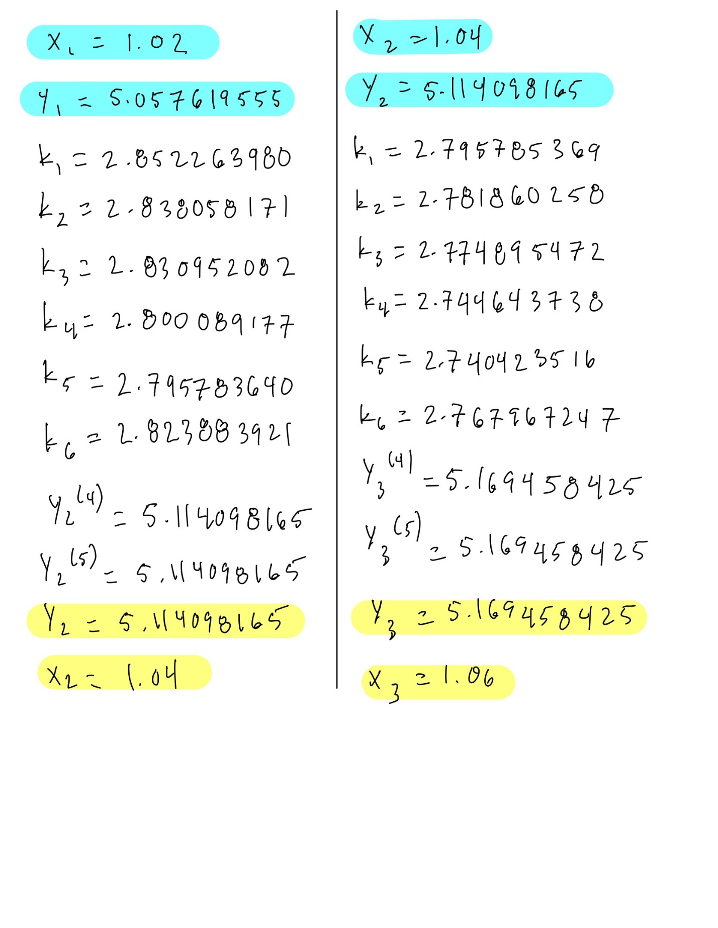

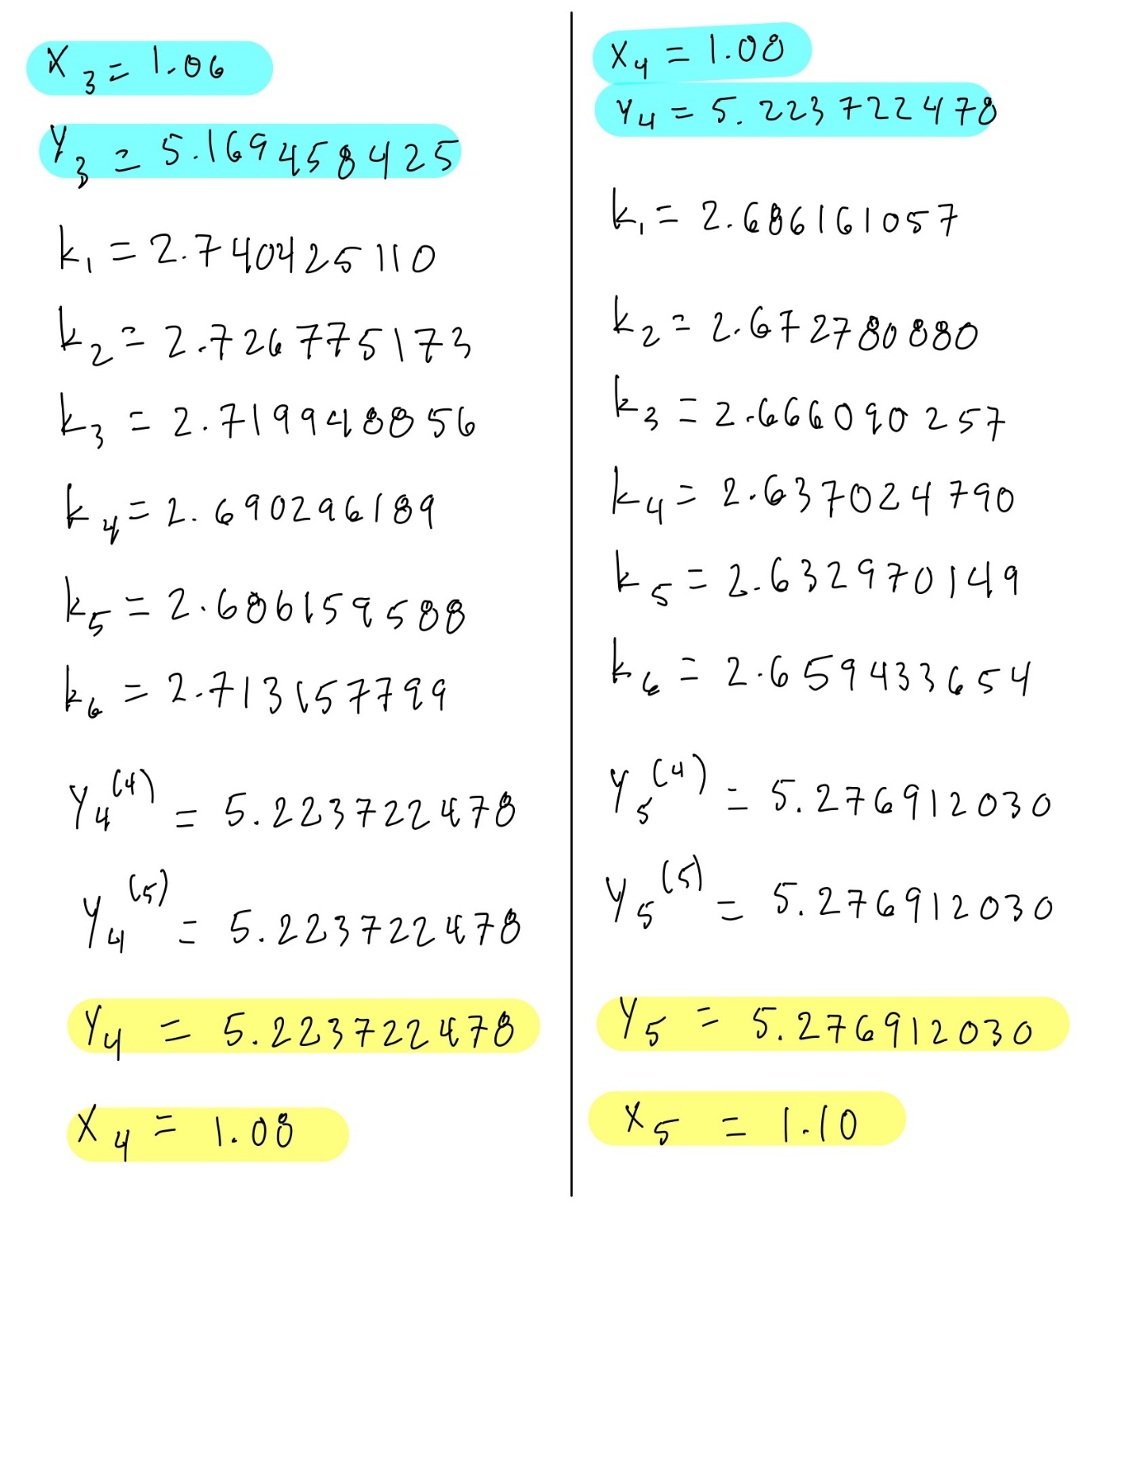

True Analytical Solution
The assigned ODE can also be solved analytically. This provides an exact solution that can be used to evaluate the accuracy of the numerical RKF45 solution.
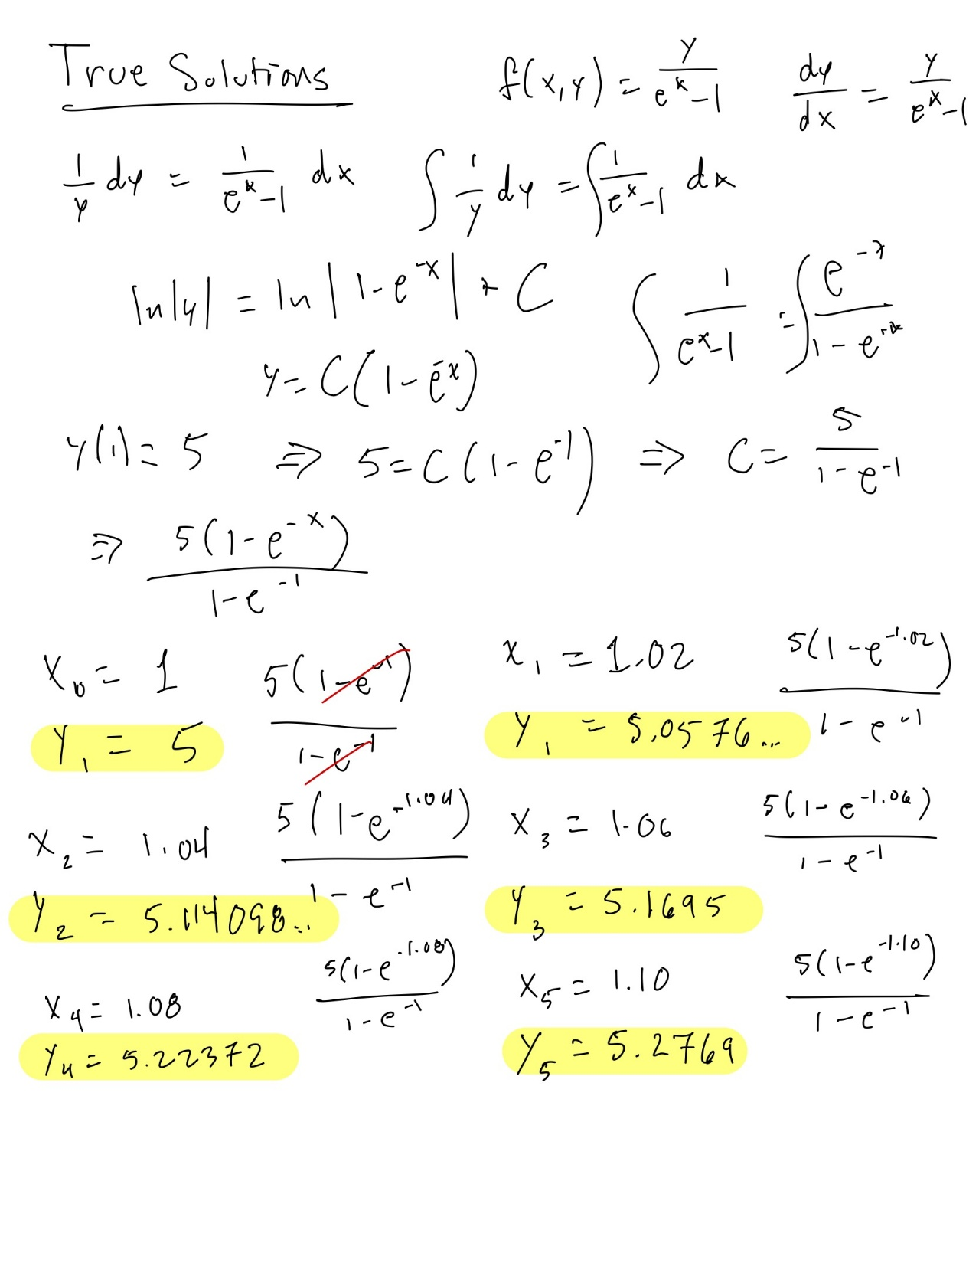
  - Numerical Results
Method: RUNGE-KUTTA METHOD
Problem: $y^{'}=\frac{y}{e^{x}-1};x_{0}=1, y_{0}=5$
$$n$$ | $$h=0.02$$ |  | True Solution
$$n$$ | $$x_{n}$$ | $$y_{n}$$ | True Solution
$$0$$ | $$1$$ | $$5$$ | 5
$$1$$ | 1.02 | 5.0576 | 5.0576
$$2$$ | 1.04 | 5.1141 | 5.1141
$$3$$ | 1.06 | 5.1695 | 5.1695
$$4$$ | 1.08 | 5.2237 | 5.2237
$$5$$ | 1.10 | 5.2769 | 5.2769

All displayed y-values and solutions are rounded to four decimal places.

- Precision and Error
RKF45 provides both fourth- and fifth-order approximations. The difference between these approximations provides an estimate of the numerical error:
$$E_{n}=y_{n+1}^{(5)}-y_{n+1}^{(4)}$$
The numerical expression is affected by the selected step size and the number of digits retained during intermediate calculations.
Using a smaller step size generally improves the accuracy of the numerical solution because the numerical approximation is made over smaller intervals. However, reducing the step size also increases the number of calculations required and therefore increases computation time.
In addition to numerical approximation error, computer calculations introduce floating-point rounding errors. Computers generally represent real numbers using finite-precision floating-point values, so some values cannot be represented exactly. For this reason, the displayed numerical results may differ slightly from the exact analytical solution.
For this assignment, intermediate values were maintained to at least nine decimal places when presenting the results. The close agreement between the RKF45 solution and the analytical solution indicates that the selected step size of h=0.02 provides a highly accurate approximation over the requested interval.

- Implementation Approach
The Python program implements the same RKF45 equations used in the manual calculations.
The general algorithm is:
- Define the function (f(x,y)).
- Read or define the initial values (x_0), (y_0), and (h).
- Calculate (k_1) through (k_6).
- Calculate the fourth-order and fifth-order approximations.
- Use the fifth-order approximation as the next (y)-value.
- Increase (x) by the step size.
- Repeat until the required number of computational steps has been completed.
- Record the number of steps performed.
- Measure the elapsed execution time.
- Display the numerical solution and performance results.
- Compare the numerical solution with the analytical solution when available.

A simplified representation of the algorithm is:
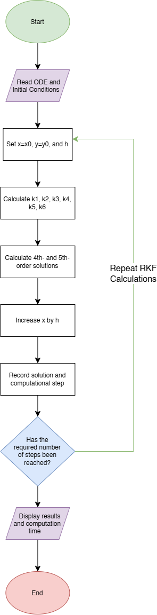
- Program Execution and Screenshots
The program was executed using Python and produced numerical solutions using the RKF45 algorithm.
The following screenshots document important stages of program execution:
Figure 1. Program Startup and Input
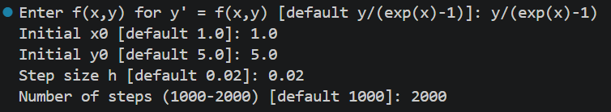
This screenshot shows the program receiving the ODE and initial conditions
Figure 2. RKF Numerical Solution
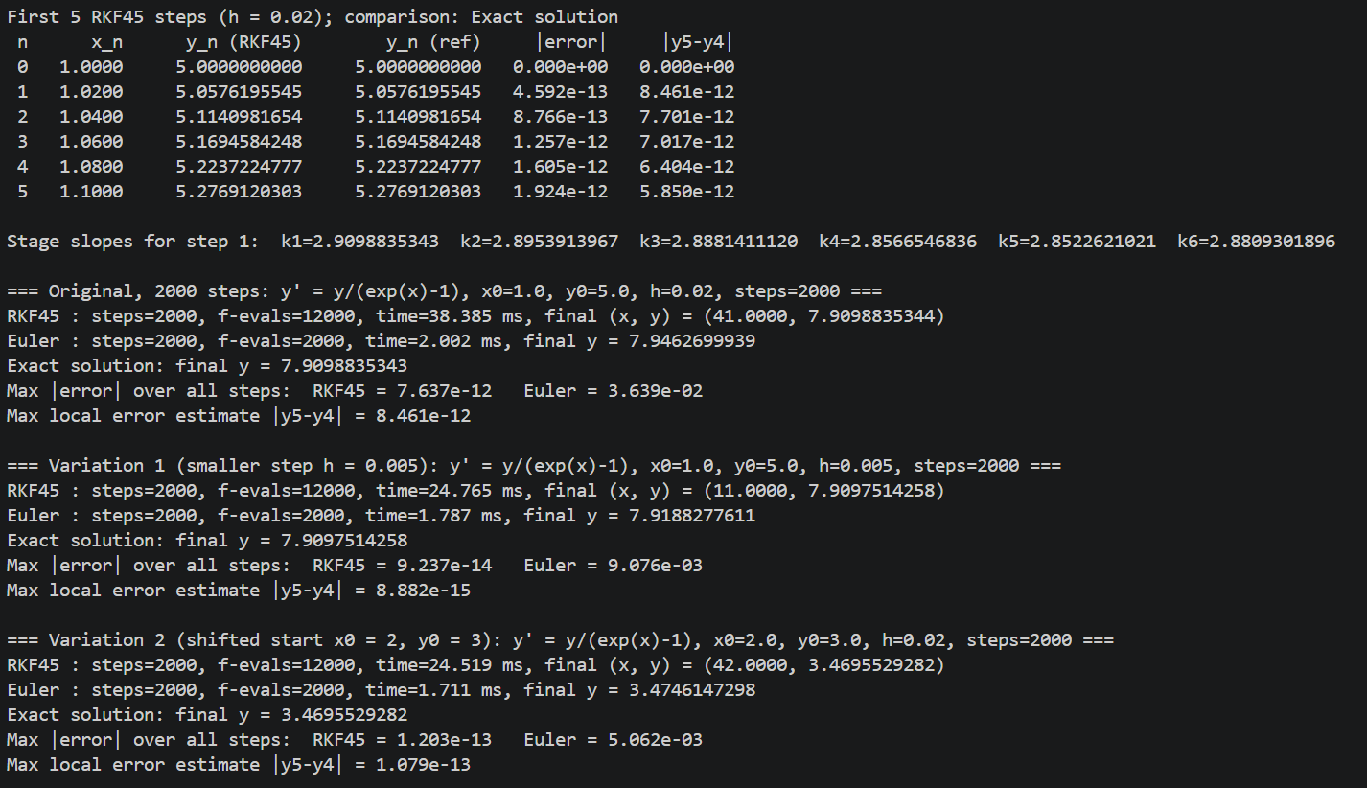
This screenshot shows the numerical solution produced by the RKF45 implementation
Figure 3. Computational Performance
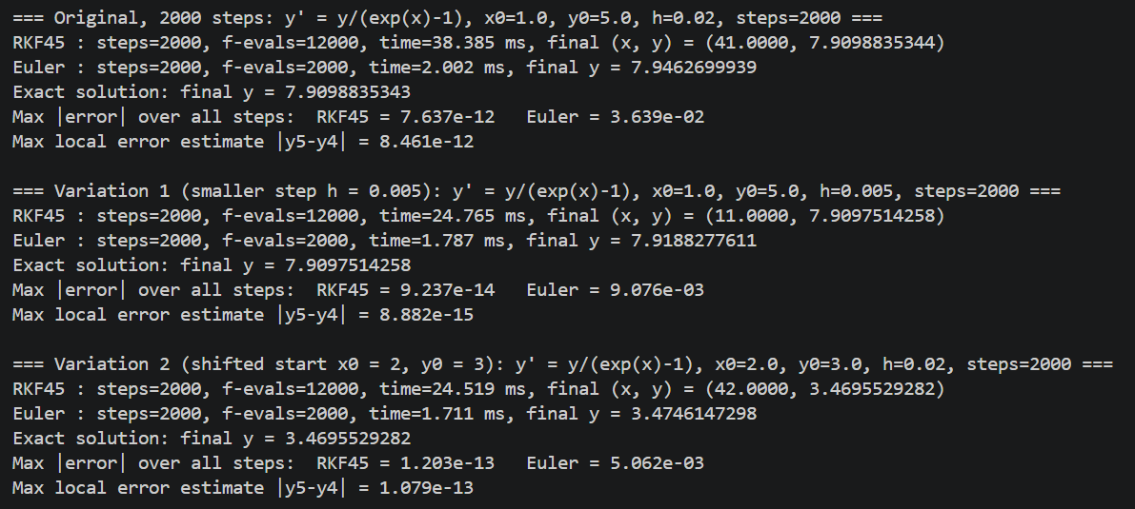
This screenshot shows the total number of computational steps and elapsed computation time.
Figure 4. Charts Produced
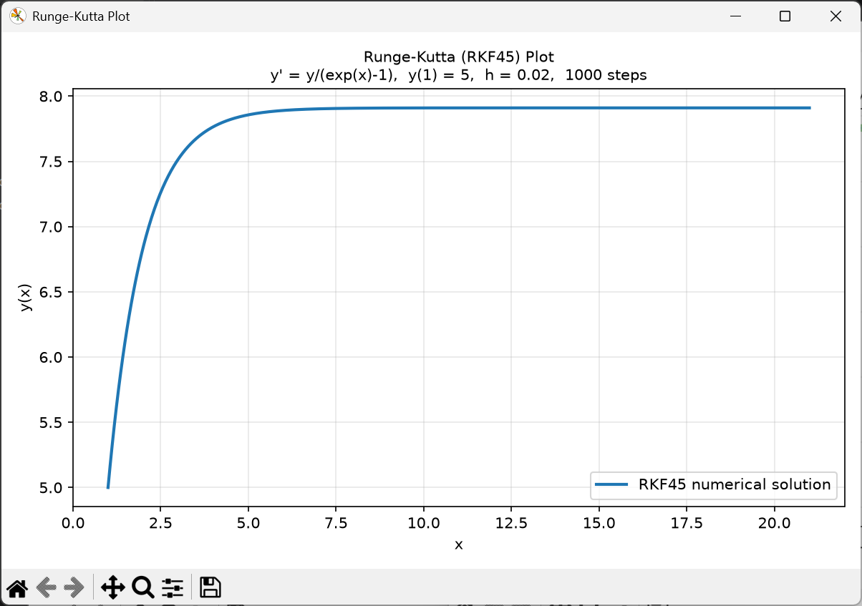
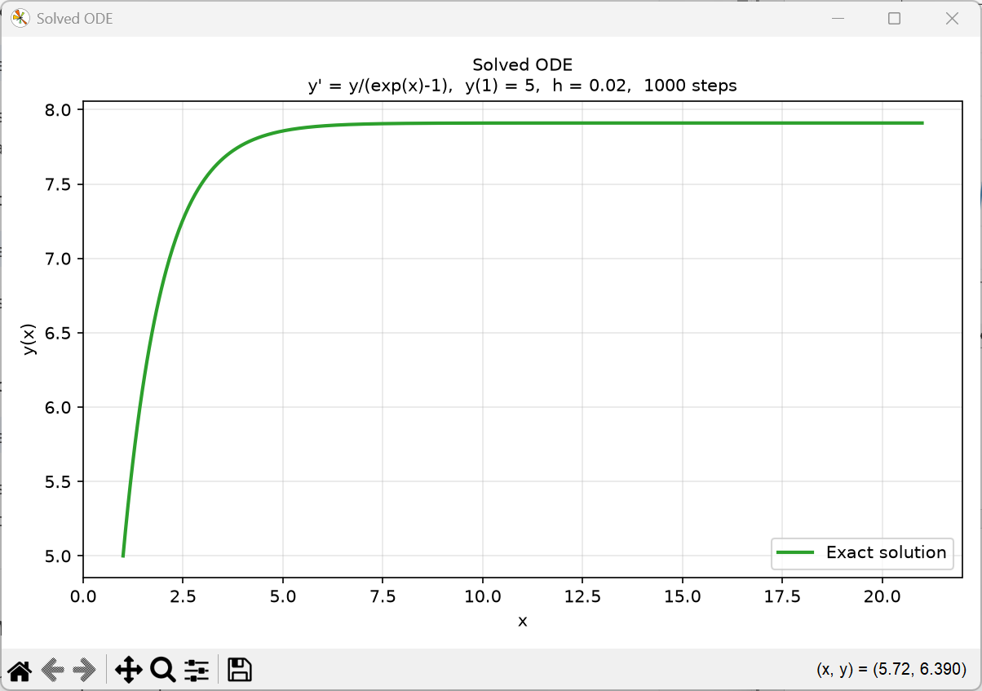
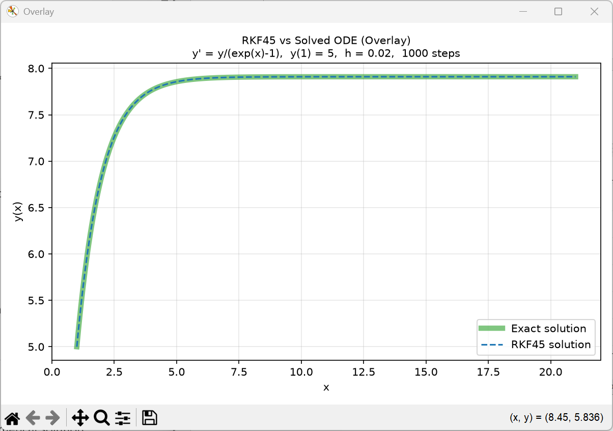
These screenshots show the charted results from the RKF45 solution (Chart 1), the exact solution to the ODE (Chart 2), and both overlayed on each other (Chart 3), with the RKF45 solution as a dotted blue line, and the exact solution as a solid green line.
- Computer Performance Timing
The program was required to perform between 1,000 and 2,000 numerical solution steps. The original problem was therefore extended beyond the five manually calculated steps.
The program records the number of computational steps and the time required to perform the calculations.
Original Problem
$$\frac{dy}{dx}=\frac{y}{e^{x}-1} , x_{0}=1, y_{0}=1, h=0.02$$
Number of steps: 2000
Execution time: 29.413 ms

Variation 1
$$\frac{dy}{dx}=\frac{y}{e^{x}-1} , x_{0}=1, y_{0}=1, h=0.005$$
Number of steps: 2000
Execution time: 24.323

Variation 2
$$\frac{dy}{dx}=\frac{y}{e^{x}-1} , x_{0}=2, y_{0}=3, h=0.02$$
Number of steps: 2000
Execution: 24.277

- Accuracy Verus Computation Time
The accuracy of a numerical solution can generally be improved by decreasing the step size. For example, changing (h=0.02) to a smaller value causes the algorithm to take more steps over the same interval.
A smaller step size provides more intermediate calculations and can reduce numerical approximation error. However, it also increases the amount of computation required. Therefore, there is a tradeoff between accuracy and computation time.
Increasing the number of calculations may improve the numerical approximation, but eventually the benefit of reducing the step size becomes smaller relative to the additional computational cost. Floating-point rounding errors can also become relevant when very large numbers of calculations are performed.
The RKF45 method is useful because it provides both fourth- and fifth-order estimates at each step. Their difference provides an indication of the local numerical error and can be used to evaluate the quality of the approximation.
- Traditional Numeric Programming Comparison
The original differential equation was also solved using the traditional numerical implementation of the RKF45 algorithm. The resulting values were compared against the manually calculated values.
The manual and program results should agree to the precision used in the manual calculations. Small differences can occur because of floating-point representation and differences in the number of digits retained during intermediate calculations.
For example, the manually calculated result at (x=1.10) is approximately:
$$y\left(1.10\right)=5.276912030$$
The corresponding program result is expected to agree closely with this value.
Any small discrepancy between the two results is attributable primarily to numerical rounding and floating-point precision rather than a fundamental difference in the RKF45 algorithm.
- Conclusion
The Runge-Kutta-Fehlberg 45 method was used to solve the assigned ordinary differential equation:
$$\frac{dy}{dx}=\frac{y}{e^{x}-1}$$
with initial conditions:
$$x_{0}=1, y_{0}=5$$
and step size:
$$h=0.02$$
Five numerical steps were performed manually, producing an approximate solution at x=1.10 of:
$$y\left(1.10\right)=5.276912030$$
The differential equation also has an analytical solution:
$$y\left(x\right)=\frac{5({1-e}^{-x})}{1-e^{-1}}$$
The close agreement between the RKF45 numerical solution and the analytical solution demonstrates the accuracy of the method for the selected step size.
The Python implementation extends the calculation to a much larger number of steps and measures the computational time required. Testing different step sizes and initial conditions demonstrates the relationship between numerical accuracy and computational cost. A smaller step size can improve numerical accuracy but requires more computational operations and therefore can increase execution time.

References
Burden, R. L., Faires, J. D., & Burden, A. M. (2016). Numerical analysis (10th ed.). Cengage Learning. https://www.cengage.com/c/numerical-analysis-10e-burden/9781305253667/
Fehlberg, E. (1969). Low-order classical Runge-Kutta formulas with stepsize control and their application to some heat transfer problems (NASA Technical Report R-315). National Aeronautics and Space Administration. https://ntrs.nasa.gov/search.jsp?R=19690021375
SciPy Developers. (2026). RK45. SciPy documentation. SciPy RK45 documentation
SciPy Developers. (2026). solve_ivp. SciPy documentation. SciPy solve_ivp documentation

